**Working of the APIs**

**GET-** Get request is used whenever we want to retrieve some data from the APIs.

**POST-** Post request is used whenever we want to send some data using the APIs.

**NOT E :-** Localhost:8080 is for local user and may change according to the server on the API gets deployed

1. UploadAndExtract API

Path of this API is :- <http://localhost:8080/pcb/api/uploadAndExtract>

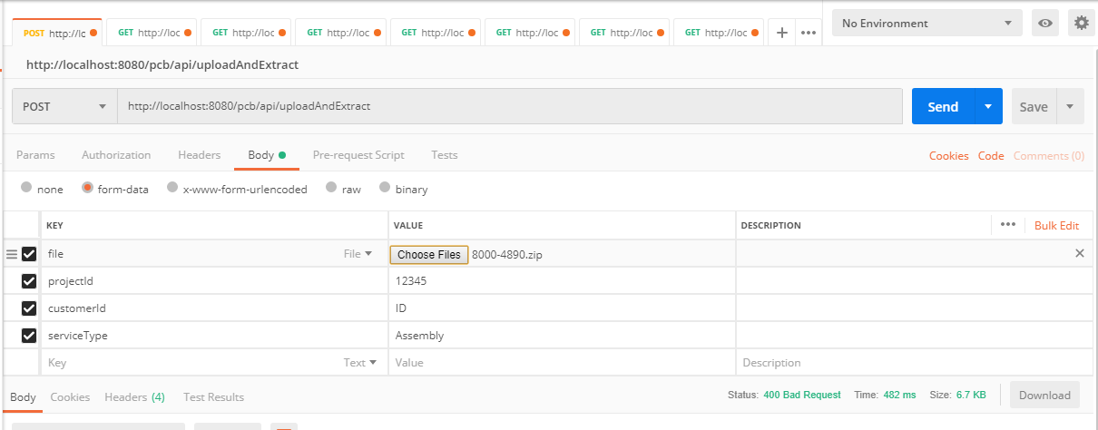

The Upload and Extract API is a POST Mapping API which means it requires some data to be sent.

In the above image we can see we are passing form data with 4 values

1 – File **(required)**

2– ProjectId (i.e FolderName) **(required)**

3 – CustomerId

4 – ServiceType

The first field i.e. File is the important field, in which user needs to choose a zip file which he/she wants to extract. After calling the Upload and Extract API the FileExtractUploadService is called which does all the processing on the file that the user will upload and categorize all the files according to the file format like Gerber files, Drill files, ODB formats and many more. Image shown below gives the output in the JSON format :-

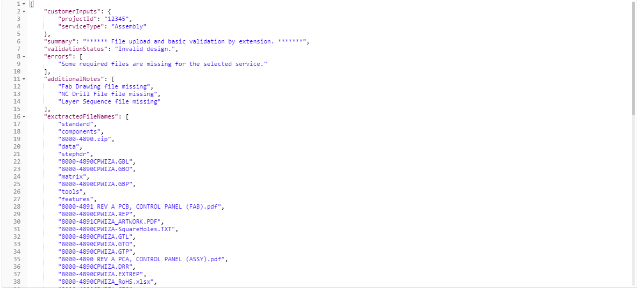

1. Get Extensions API

Path of this API is :- <http://localhost:8080/pcb/admin/extensions>

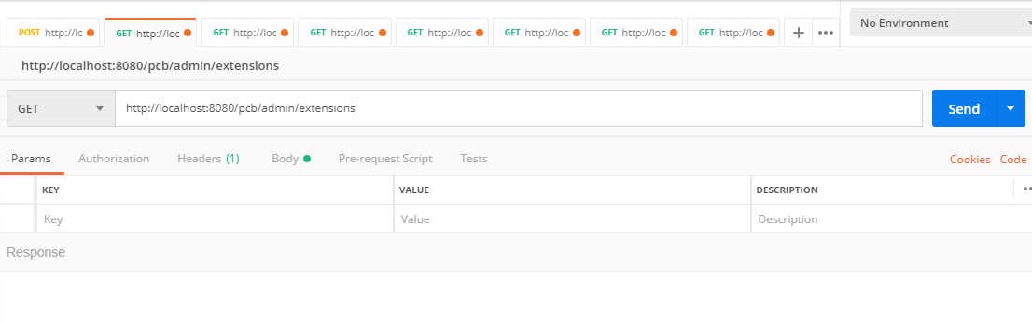

The Get Extensions API is a GET Mapping API which is very simple to use just add the path and hit the send request and the result will be displayed to the user in the JSON Response. The result contains all the extensions that are contained in the file with its id that user have uploaded. This API will call the FileExtensionService which has findAll() method for getting all the file extensions. Below image shows the output of the API in a JSON Format:-

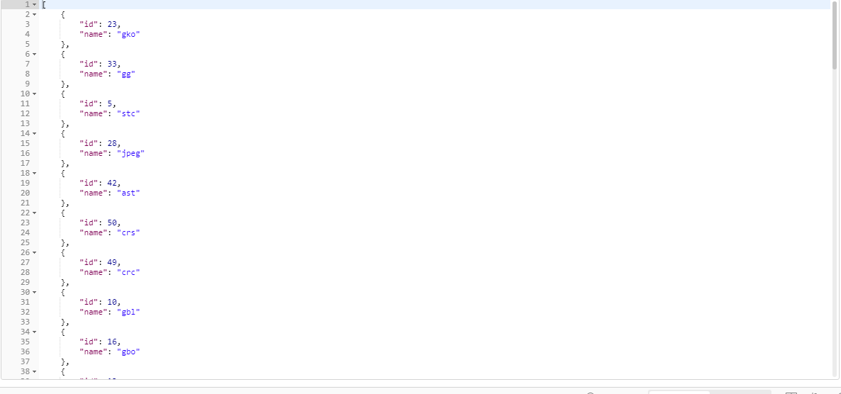

1. CreateExtensions API

Path of this API is : <http://localhost:8080/pcb/admin/extensions/create>

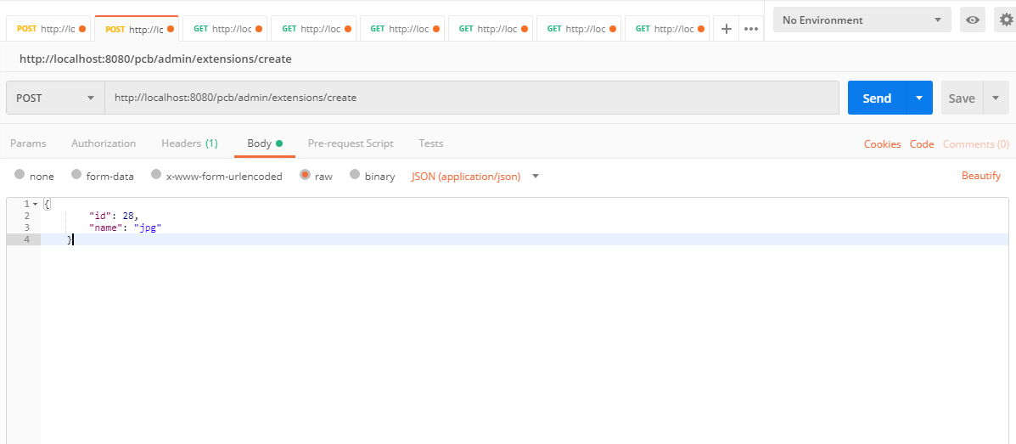

The Create Extensions API is a POST Mapping API which takes the JSON Response. The JSON contains id and extension in the request. This API will call the FileExtensionService which has save () method for saving the file extensions. Below image shows the output of the API that is Status: 200 OK in Green color which means our API is working properly:-

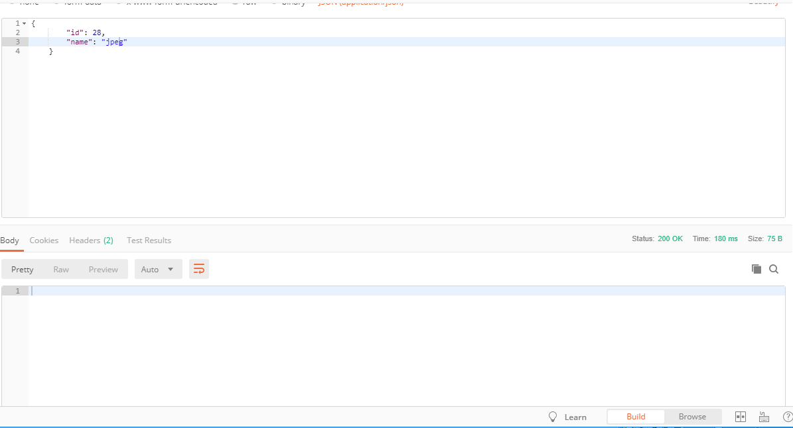

1. Get Extension By Id API

Path of this API is : [http://localhost:8080/pcb/admin/extensions/retrive/**{ID}**](http://localhost:8080/pcb/admin/extensions/retrive/%7bID%7d) 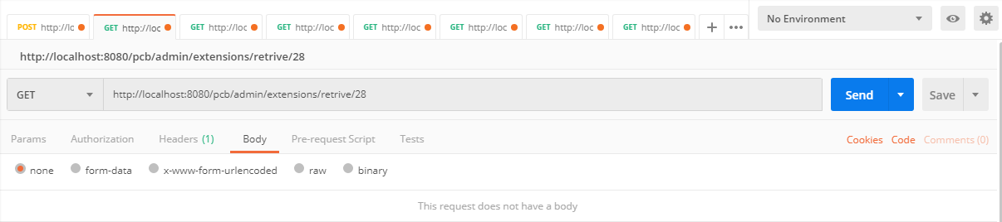

The Get Extension by Id API is a GET Mapping API which takes argument in the URL which is the id of the extension that you want to get from the database. The output will be In JSON format which contains id and extension in the response. This API will call the FileExtensionService which has getExtensionById() method for retrieving the file extensions. Below image shows the output of the API:-

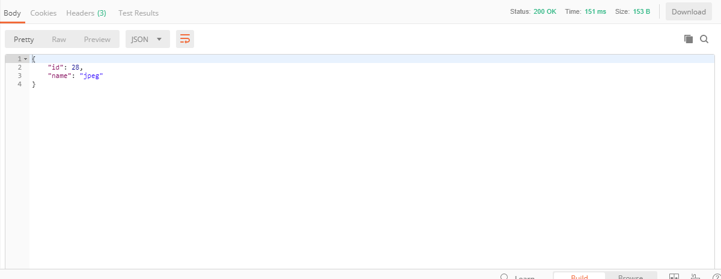

1. Get Services API

Path of this API is <http://localhost:8080/pcb/admin/services/>

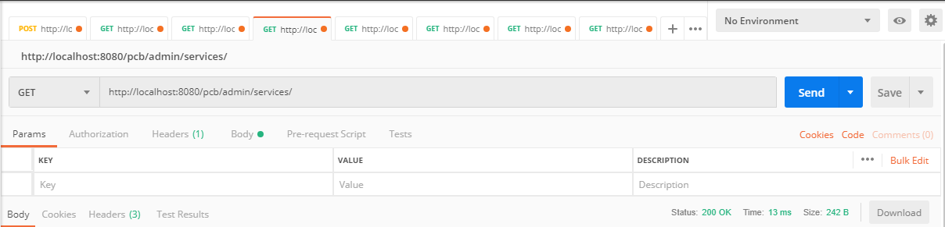

The Get Services API is a GET Mapping API which is a very simple API; User just needs to hit the URL and the output will be In JSON format which contains id and name of the service in the response. The Get Services API will call the FileServices which has a findAll() method which gets all the id and services name. The output is shown below:-

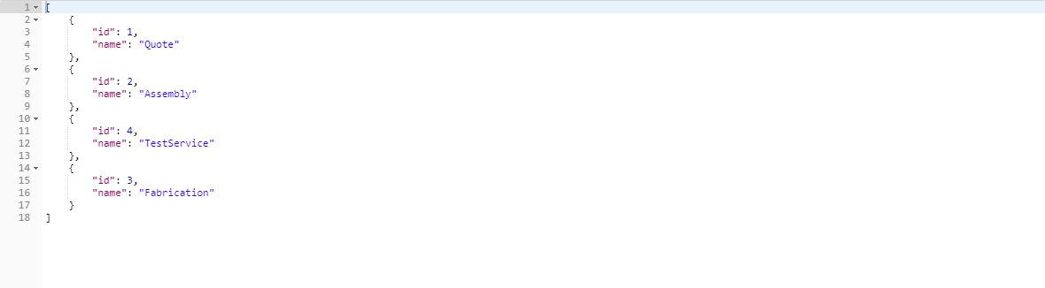

1. Create Services

Path of this API is <http://localhost:8080/pcb/admin/services/create>

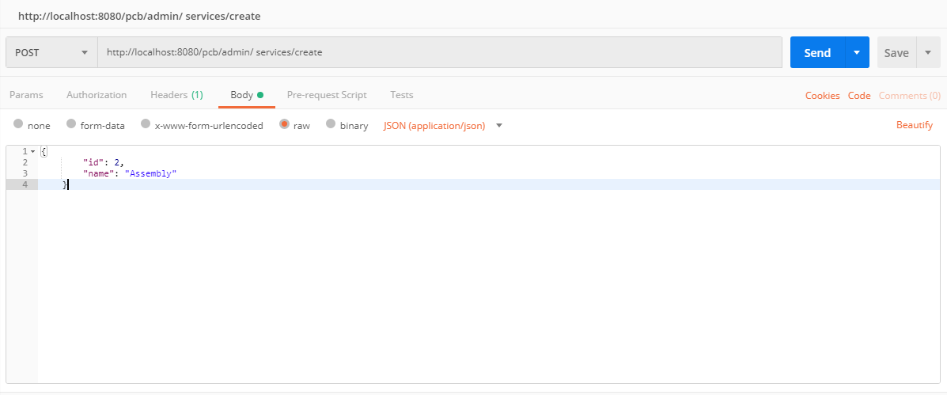

The create Service API is a POST Mapping API which takes the JSON Response. The JSON contains id and service name in the request. This API will call the FileService which has save () method for saving the file services. Below image shows the output of the API that is Status: 200 OK in Green color which means our API is working properly:-

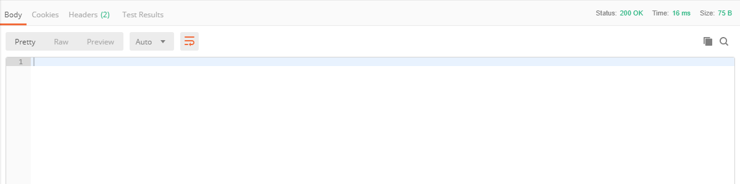

1. Get Services By Id

Path of this API is [http://localhost:8080/pcb/admin/services/retrive/**{ID}**](http://localhost:8080/pcb/admin/services/retrive/%7bID%7d)

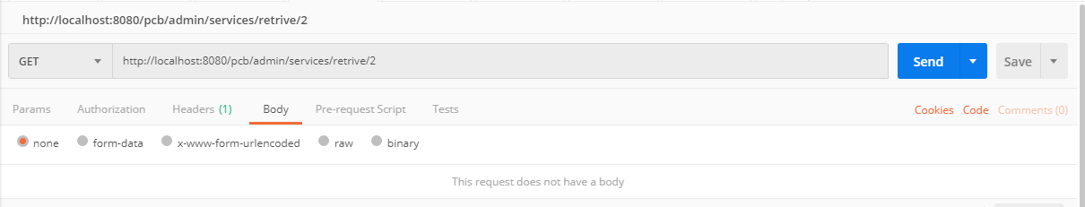

The Get Services By Id API is a GET Mapping API which takes argument in the URL I.e. service Id of the service which you want as a response. This API calls the FileService which has getServicesById() method for retrieving the FileServices. Below image shows the output of the API:-

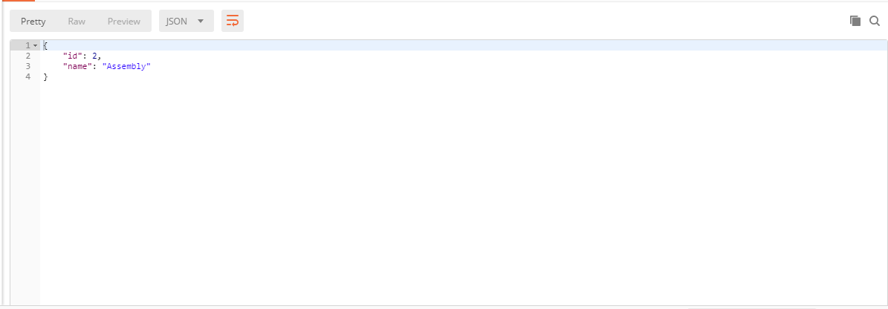

1. Get FileTypes

Path of this API is <http://localhost:8080/pcb/admin/filetypes/>

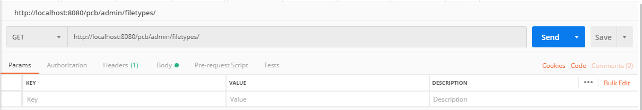

The Get Filetypes API is a GET Mapping API which is a very simple API; User just needs to hit the URL and the output will be In JSON format which contains id and name of file extensions in the response. This API calls the FileTypeService which has findAll() method to get all the filetypes.Below image shows the output in JSON format.

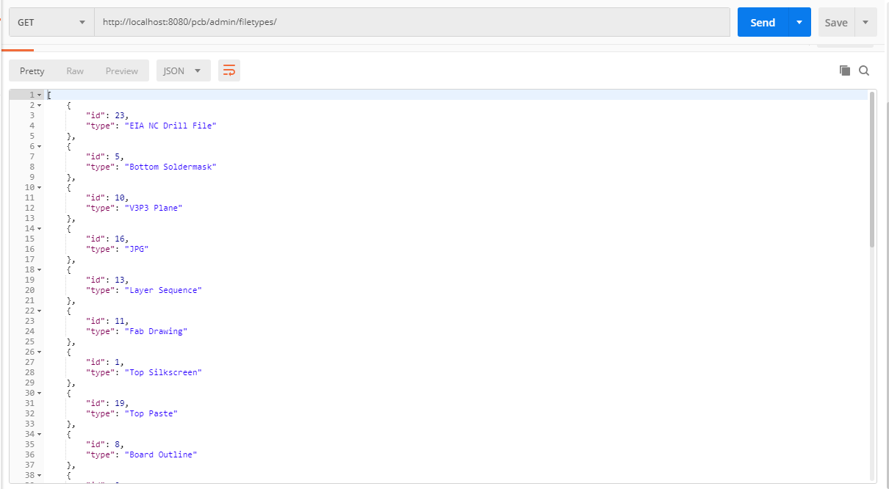

1. Create FileTypes

Path of this API is <http://localhost:8080/pcb/admin/filetypes/create>

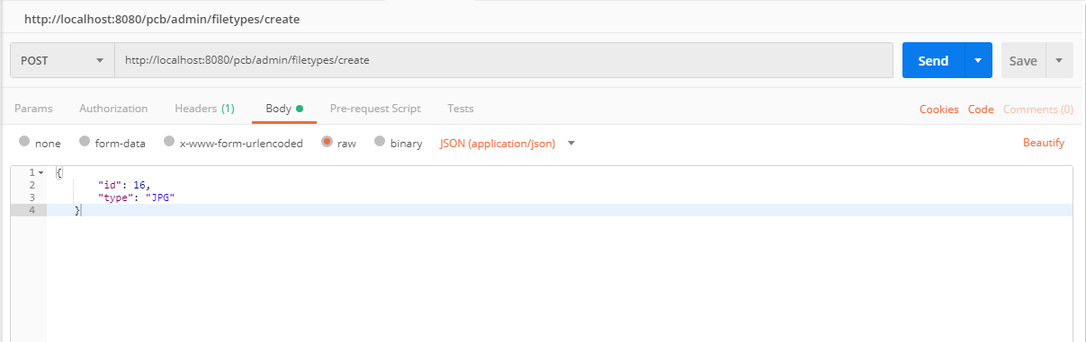

The create Filetype API is a POST Mapping API which takes the JSON Response. The JSON contains id and filetype in the request. This API will call the FileTypeService which has save () method for saving the file type. Below image shows the output of the API that is Status: 200 OK in Green color which means our API is working properly:-

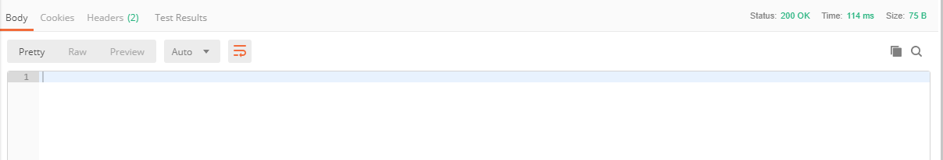

1. Get Filetype By Id

Path of this API is [http://localhost:8080/pcb/admin/filetypes/retrive/**{ID}**](http://localhost:8080/pcb/admin/filetypes/retrive/%7bID%7d)

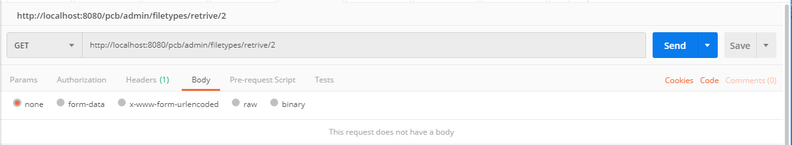

The Get Filetype By Id API is a GET Mapping API which takes argument in the URL I.e. filetype Id of the filetype which you want as a response. This API calls the FileTypeService which has getTypeById() method for retrieving the Filetypes. Below image shows the output of the API:-

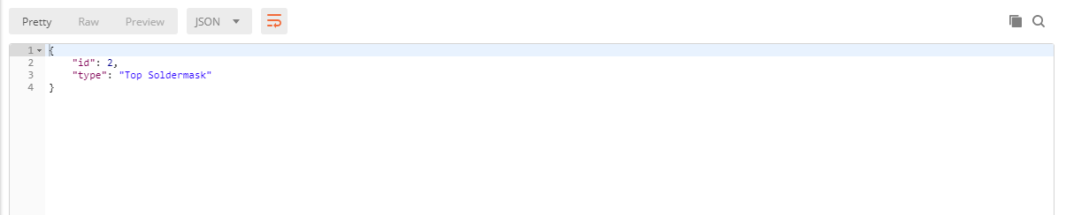

1. Get ServiceFiles

Path of this API is <http://localhost:8080/pcb/admin/servicefiles>

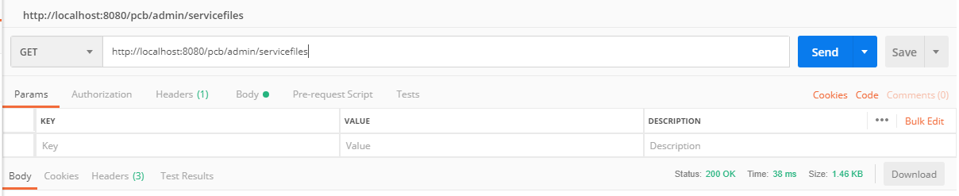

The Get ServiceFiles API is a GET Mapping API which is a very simple API; User just needs to hit the URL and the output will be In JSON format which contains composite key of serviceId and filetypeId , service, file, filetypeId, serviceId of servicefiles in the response. This API calls the ServiceFilesService which has findAll() method to get all the servicefiles.Below image shows the output in JSON format:-

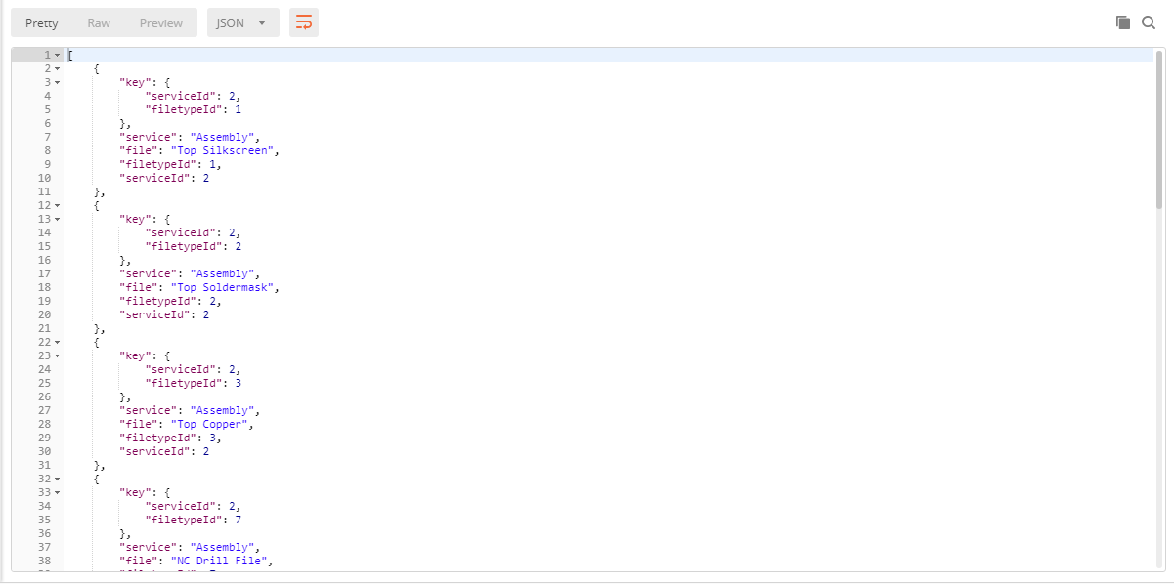

1. Create ServiceFiles

Path of this API is <http://localhost:8080/pcb/admin/servicefiles/create>

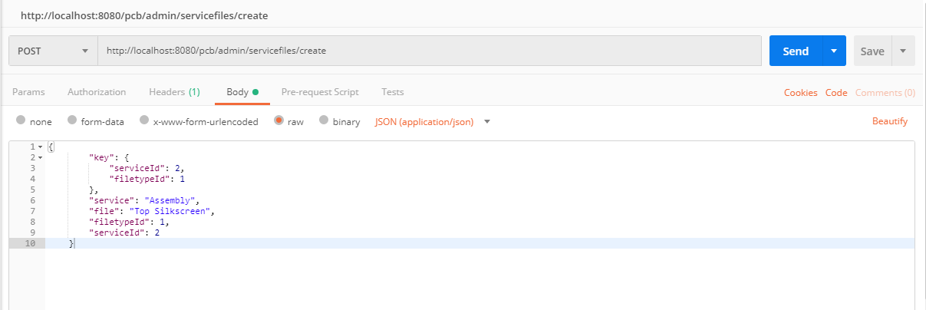

The create ServiceFiles API is a POST Mapping API which takes the JSON Response. The JSON contains composite key of serviceId and filetypeId , service, file, filetypeId, serviceId in the request. This API will call the ServiceFilesServices which has save () method for saving the Service Files. Below image shows the output of the API that is Status: 200 OK in Green color which means our API is working properly:-

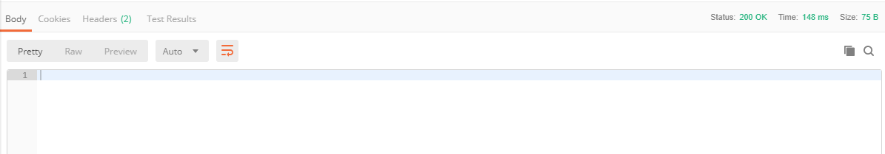

1. Get ServiceFiles By Service Id

Path of this API is [http://localhost:8080/pcb/admin/servicefiles/retrive/**{ID}**](http://localhost:8080/pcb/admin/servicefiles/retrive/%7bID%7d)

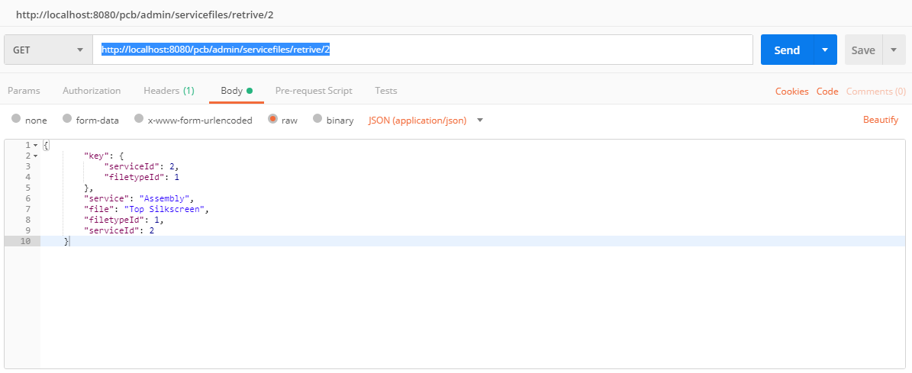

The Get ServiceFileByServiceId API is a GET Mapping API which takes argument in the URL I.e. service Id of the ServiceFiles which you want as a response. This API calls the ServiceFilesServices which has getFilesByService() method for retrieving the ServiceFiles. Below image shows the output of the API:-

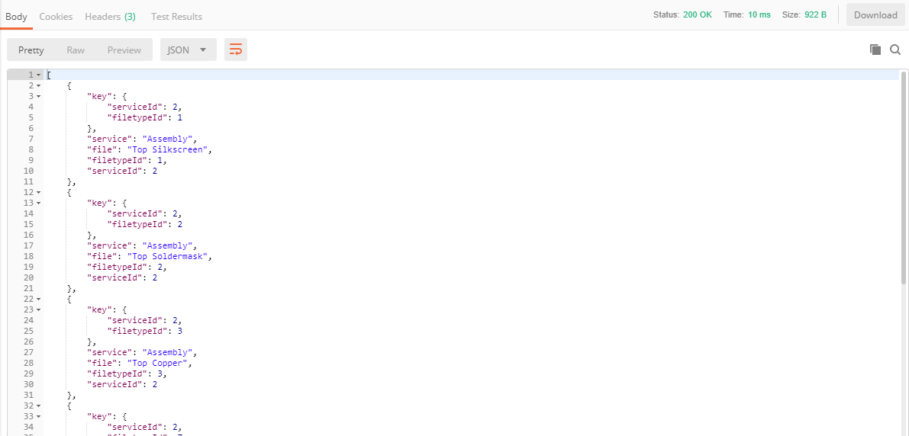

1. Create ServiceFiles with Multiple Arguments

Path of this API is <http://localhost:8080/pcb/admin/servicefiles/createmulti>

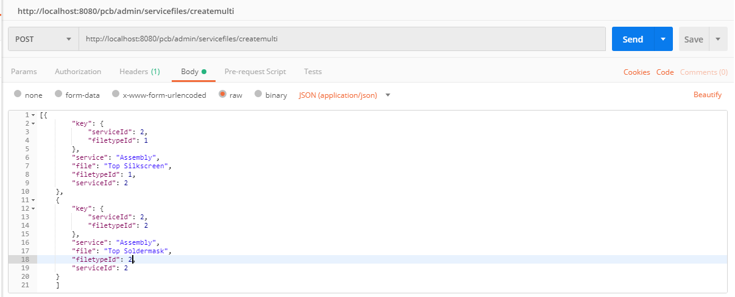

The create ServiceFilesMulti API is a POST Mapping API which takes the Array of JSON Response. The JSON contains a composite key of serviceId and filetypeId , service, file,filetypeId, serviceId in the request. This API will call the ServiceFilesServices which has saveAll () method for saving the Service Files. Below image shows the output of the API that is Status: 200 OK in Green color which means our API is working properly:-



1. Get ExtensionFiles

Path of this API is <http://localhost:8080/pcb/admin/extensionfiles>

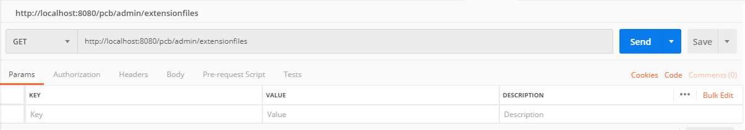

The Get ExtensionFiles API is a GET Mapping API which is a very simple API; User just needs to hit the URL and the output will be In JSON format which contains a composite key of extensionId and filetypeId, extension, file, filetypeId, extensionId of extensionFiles in the response. This API calls the ExtensionFileService which has findAll() method to get all the extensionfiles.Below image shows the output in JSON format:-

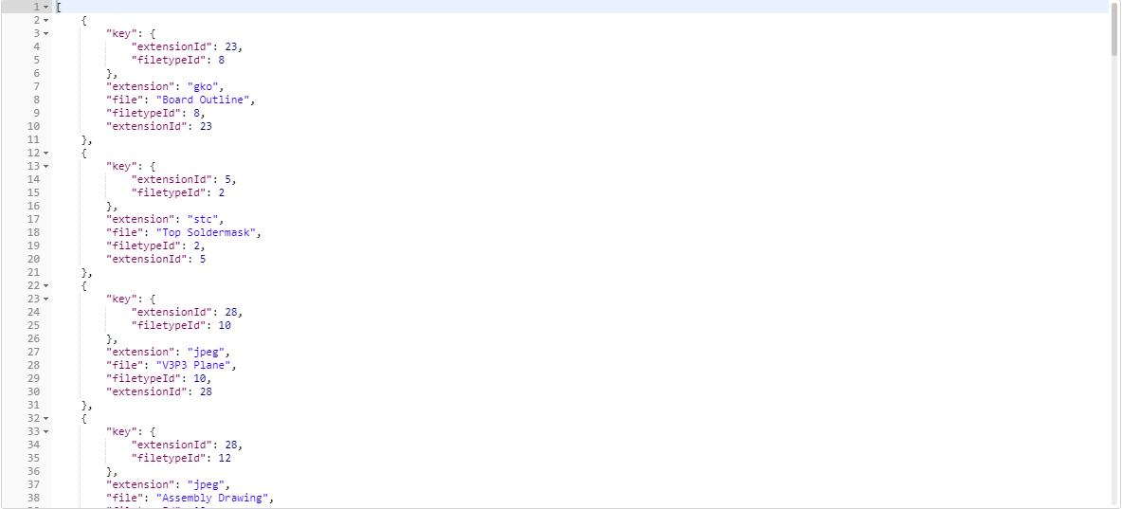

1. Create ExtensionFiles

Path of this API is <http://localhost:8080/pcb/admin/extensionfiles/create>

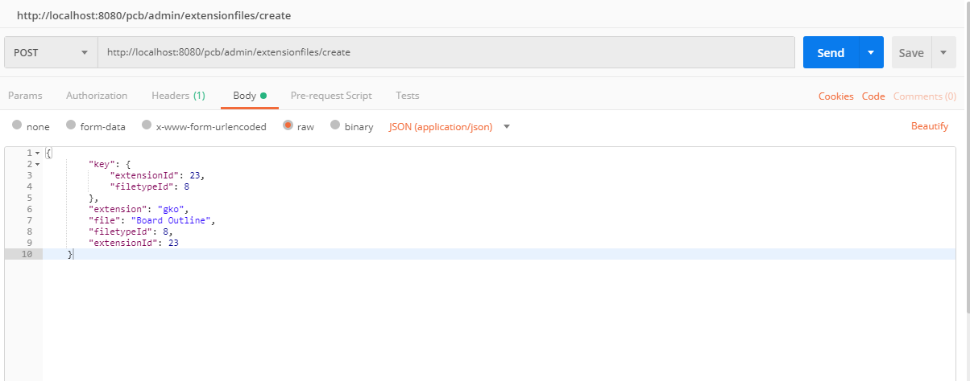

The create ExtensionFiles API is a POST Mapping API which takes the JSON Response. The JSON contains composite key of extensionId and filetypeId , extension, file, filetypeId, extensionId in the request. This API will call the ExtensionFileService which has save () method for saving the Extension Files. Below image shows the output of the API that is Status: 200 OK in Green color which means our API is working properly:-



1. Create ExtensionFiles with Multiple Arguments

Path of this API is <http://localhost:8080/pcb/admin/extensionfiles/createmulti>

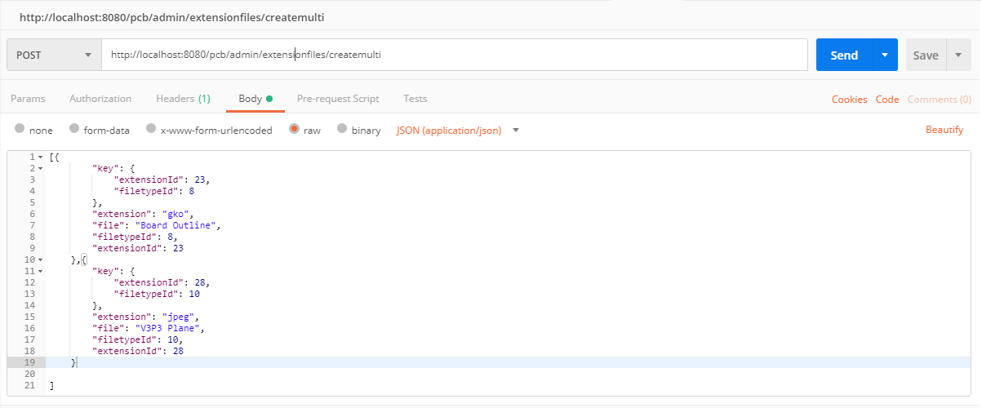

The create ExtensionFiles API is a POST Mapping API which takes the Array JSON Response. The JSON contains composite key of extensionId and filetypeId , extension, file, filetypeId, extensionId in the request. This API will call the ExtensionFileService which has saveAll () method for saving the Extension Files. Below image shows the output of the API that is Status: 200 OK in Green color which means our API is working properly:-



1. Get ExtensionFilesByFiletypeId

Path of this API is [http://localhost:8080/pcb/admin/extensionfiles/retrive/**{ID}**](http://localhost:8080/pcb/admin/extensionfiles/retrive/%7bID%7d)

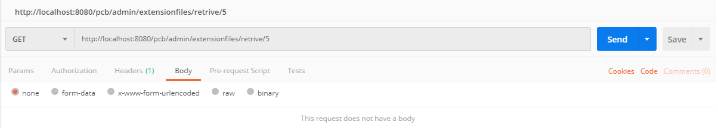

The Get ExtensionFileByFiletypeId API is a GET Mapping API which takes argument in the URL I.e. filetype Id of theExtensionFiles which you want as a response. This API calls the ExtensionFileService which has getExtenFileTypeById () method for retrieving the ExtensionFiles. Below image shows the output of the API:-

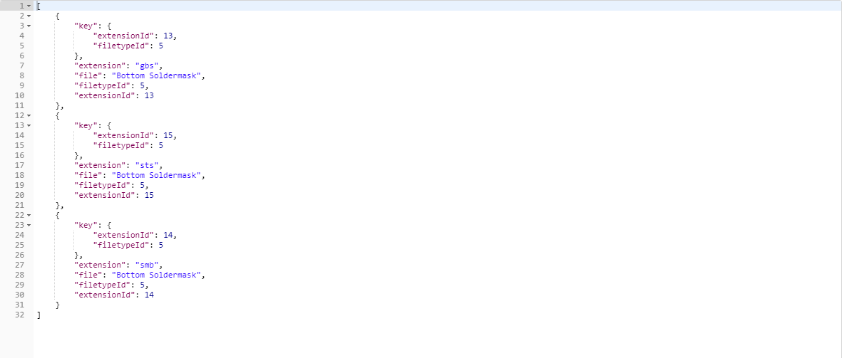

1. Get Report

Path of this API is <http://localhost:8080/pcb/admin/report/>

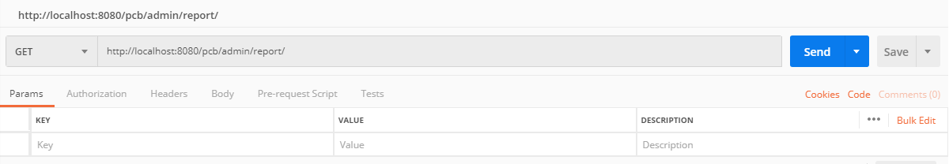

The Get Report API is a GET Mapping API which returns the whole report; User just needs to hit the URL and the output will be In JSON format which contains a composite key of projectId and version, customerId, serviceTypeId, summary, fileTypeToFileNameMapping, errors, notes, projectFiles, status, version, projectId in the response. This API calls the ReportServices which has findAll() method to get all the reports.Below image shows the output in JSON format:-

